arvest Temple Christian Academy
“Preparing Minds to Lead and Hearts to Serve for God’s Glory”

Elementary (2nd-3rd Grade) Supply List (2023/24)

Every Student Needs:
- Sneakers for gym (These will be kept at school)
- Lunch box/backpack (Please see guidelines in handbook.)
- #2 pencils – 3 dozen (Ticonderoga brand is recommended. Other brands don’t sharpen well.)
- Erasers
- Crayons (at least 24 colors)
- Scissors (Fiskars style)
- Elmer’s glue sticks
- 2 school boxes
- 5 pocket folders
- KJV Bible
- Wide-lined paper (2 packages)
- Headphones (for technology class)
- Ruler-non collapsible
- Tissues – 3 boxes
- Disinfectant wipes – 2 packages
- Paper towels – 1 roll
- Washable colored markers
- Colored pencils (12-24 count)
- Coloring book
- Drawing paper

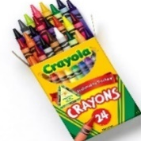
Harvest Temple Christian Academy
www.htcaclyde.com │ 419-547-8251
Clyde, OH

