arvest Temple Christian Academy
“Preparing Minds to Lead and Hearts to Serve for God’s Glory”

Preschool (K4) Supply List (2023/24)

Every Student Needs:
- 1 change of clothes including underwear and socks in a zip lock bag (These are left at school)
  - Please make sure the items are weather appropriate.
- Backpack
- Plastic crayon box
- 1 – 24 pack of crayons
- 1 container of Lysol wipes
- 1 pocket folder
- Crayola basic 8 paints with brush
- Paint Shirt (can just be an old t-shirt)
- 1 pack of Glue sticks
- Scissors
- 1 package of pencils
- 3 boxes of tissues
- 1 pack of skinny markers
- 1 pack of colored pencils

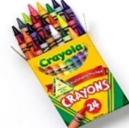

Harvest Temple Christian Academy
www.htcaclyde.com │ 419-547-8251
Clyde, OH

