
arvest Temple Christian Academy
“Preparing Minds to Lead and Hearts to Serve for God’s Glory”

Elementary (1st-2nd grade) Supply List

Every Student Needs:
- Lunchbox/backpack
- Gym clothes (bring weekly, please see guidelines in handbook)
- KJV Bible
- Headphones
- 2 pencil boxes
- 2 pocket folders
- 2 dozen #2 pencils (Ticonderoga brand recommended)
- 2 Erasers (white or pink)
- Crayons (24 colors)
- Colored pencils (12-24 count)
- 3 Elmer's glue Sticks
- Scissors (Fiskars style)
- Ruler (non-bending, inches & metric)
- 2 boxes of tissues
- 2 rolls of paper towels
- 1 package of baby wipes or hand sanitizing wipes
- No personal pencil sharpeners


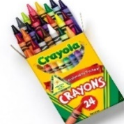
Harvest Temple Christian Academy
www.htcaclyde.com │ 419-547-8251
Clyde, OH

