
arvest Temple Christian Academy
“Preparing Minds to Lead and Hearts to Serve for God’s Glory”

Elementary (3rd-4th Grade) Supply List

Every Student Needs:
- Lunch box/ backpack
- Gym clothes (bring weekly, please see guidelines in handbook)
- KJV Bible
- Headphones
- Pencil box
- 3 pocket folders
- 1 - 1" 3-ring hard binder
- 5-pack of divider tabs for binder
- 2 packs of wide-ruled loose-leaf paper
- 2 dozen #2 pencils (Ticonderoga brand recommended)
- 2 Erasers (white or pink)
- Crayons or colored pencils (24 pack)
- 3 Elmer's glue sticks
- Scissors
- Ruler (non-bending, inches & metric)
- 2 boxes of tissues
- 2 packages of wipes
- 2 rolls of paper towels
- No personal pencil sharpeners


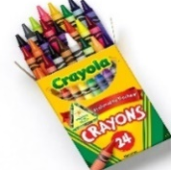
Harvest Temple Christian Academy
www.htcaclyde.com │ 419-547-8251
Clyde, OH

