
arvest Temple Christian Academy
“Preparing Minds to Lead and Hearts to Serve for God’s Glory”

Preschool (K4) Supply List

Every Student Needs:
- 1 change of clothes including underwear and socks in a zip lock bag (These are left at school)
  - Please make sure the items are weather appropriate.
- Backpack
- Lunchbox (Full-Day students and Half-Day w/ lunch)
- Plastic crayon box
- 1 – 24 pack of crayons
- 1 green pocket folder (plastic)
- 1 pack of Glue sticks
- Scissors
- 1 package of pencils (#2 Ticonderoga brand recommended)
- 1 package of markers
- 1 boxes of tissues
- 1 pack of colored pencils
- 1 pack of fat markers
- 1 pack of skinny markers


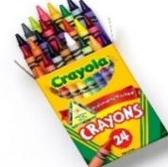

Harvest Temple Christian Academy
www.htcaclyde.com │ 419-547-8251
Clyde, OH

