
arvest Temple Christian Academy
“Preparing Minds to Lead and Hearts to Serve for God’s Glory”

Elementary (K5) Supply List

Every Student Needs:
- 1 change of clothes, including underwear and socks (These are left at school)
  - Please make sure the items are weather appropriate.
- Lunch box/backpack (Please see guidelines in handbook.)
- 1 package of #2 pencils (Ticonderoga brand is recommended)
  - Please avoid plastic coated pencils. They clog the sharpeners.
- 2 erasers
- Crayons (no fat ones; 24 colors) – 2 boxes
- Scissors (Fiskars style)
- Elmer glue sticks (5 pack)
- 2 School boxes
- 1 yellow pocket folder (plastic)
- KJV Bible
- Colored Pencils – 2 boxes
- Tissues – 3 boxes
- Paper Towels – 3 rolls
- Washable colored markers – 2 boxes
- NO Personal Pencil Sharpeners

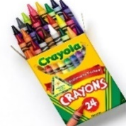
- No blankets for nap are needed

Harvest Temple Christian Academy
www.htcaclyde.com │ 419-547-8251
Clyde, OH

